Automatic Email Generation for Low Attendance

Sonal shruti
Department of Computer Science & Engineering
Greater Noida Institute of Technology
Greater Noida
Sudhir Kumar Department of Computer Science & Engineering Greater Noida Institute of Technology
Greater Noida
Shwetank Shukla Department of Computer Science & Engineering Greater Noida Institute of Technology
Greater Noida
Department of Computer Science & Engineering
Greater Noida Institute of Technology
Greater Noida
Rakesh Raushan
Department of Computer Science & Engineering
Greater Noida Institute of Technology
Greater Noida

Abstract

In today growing population age, managing student attendance is essential for academic success but can be time consuming and requires more man power. The Automatic Email Generation for low attendance project automates the detection of students with low attendance using Automation Anywhere, an Robotic Process Automation (RPA) tool. The system monitors attendance directory, identifies student below predefined threshold, and automatically generates personalized email alerts. This helps in informing students of their present attendance status and encourage improvements to avoid academic consequences. System runs periodically, reducing the need for manual monitoring and interaction. This modernized approach helps administrators efficiently manages attendance, proactively address attendance issues, and maintain consistent student engagement through automated reminders. This solution saves administrative time and promotes better attendance habits for academic success.
Keywords— Robotic Process Automation; attendance directory; CNN; LBP; manual monitoring; POC; UiPath; HRMS.

Introduction
student engagement and performance. However, traditional methods of tracking attendance and notifying students with low attendance are often labour-intensive, error-prone, and inefficient. With increasing class sizes and growing administrative demands, there is a pressing need for automated solutions to address these challenges.

This research paper focuses on developing an "Automatic Email Generation for Low Attendance" system using Robotic Process Automation (RPA). The proposed system utilizes RPA tools, such as Automation Anywhere, to automate the process of identifying students with attendance below a predefined threshold and sending personalized email alerts. The automation ensures accuracy, consistency, and timely communication, reducing manual intervention and minimizing administrative efforts.

By integrating RPA into attendance management, this approach not only enhances operational efficiency but also fosters accountability among students by providing timely reminders. This paper explores the design, implementation, and potential benefits of the system, highlighting its scalability and adaptability for use in various academic environments. The research aims to demonstrate how automation can transform routine administrative tasks into seamless processes, paving the way for smarter educational management systems.

Attendance monitoring is a crucial aspect of academic institutions, serving as a key indicator of

Literature Review

“Student Attendance Management system: A Review And Future Research Directions” in year 2018 by K.Jacksi, F.H.Mohammed. “Student Attendance Management system” is a buzzword that represents a move towards more technology- enhanced learning.[1] Technologies such as Robotic Process Automation, personalized attendance tracking, grading, and student performance analysis.[2] This system also incorporate smart education technologies such as personalized learning, adaptive assessments, and virtual classrooms tom provide an engaging and effective learning experience for students. In this tool which is being incorporated are UiPath, CNN and Local Binary Patterns (LBP)for face recognition [1][3].

“Face Recognition Attendance System using RPA” in year 2020 paper written by A.Shetty, P.Nayak, N.prasad, P.P.Sheety, P.karkera. Suggest to develop a smart attendance system over a simple attendance system.[4] To do so they proposed a system where camera is used to capture the images/videos. From camera the images of the students are extracted and is given as input to processor raspberry pie. Database will store all these details of students such as name, other facial features. [5] In processor the images extracted from the camera and images given in the databases are compared by preprocessing the data first. If the details of the extracted images matches the features of stored in database then for that particular period of attendance will be marked in MS excel. [3][6]Then by using RPA the attendance result is extracted from excel sheet is marked in web application according to their credentials [7].

“Attendance Management System using RPA” in year 2021 featuring H.Prajapati, A.Rane, K.Vanve, A.Chintawar proposed a software robot using UiPath software. This robot will take the file path where your excel sheet is stored and read and extract all the data written init. It will then perform all the calculation like Total Present, Total Absent, Total working days, Percentage and feedback.All this is achieved by using the various activities provided by UiPath software [8].
“Imroving Efficiency and Effectiveness of RPA in Humann Resource Management” in year 2022 written by S.A.Mohammad, M.A.Mahmoud, M.N.Mahdi, S.A.Mostafa. Researcher Proposed that with RPA in HRMS, the organization can improve process efficiency and effectiveness to improve productivity. [9] Robots can performs a task every day, continuously, without human monitoring and can produce task error-free, which leads to a ahigh quality and quantity of data production. RPA was developed in the presentation layer of the HRMS process to automate structured data in accessing, gathering, and storing employees’ records. [10][12] This study contributes to organization in the HR department via implementing the RPA process to increase an understanding of how RPA is adopted and implemented in an attempt to create value. This method includes process assessment, proof of concept (POC), project design and build [11].

“Student Mentoring System Using Robotics Process Automation In Engineering Education” in year 2023 researched by S.C. Reddy S.Akash, DR. Akash R, kavya D, Lavanya A proposed a web-based platform tasks such that leverages RPA to automate Adminstrative as attendance tracking, grading, and student performance analysis. [13]The system will also incorporate smart education technologies such as personalized learning , adaptive assessments , and virtual classrooms to provide an engaging and effective learning experience for students.[14] By using this students can receive consistent and objective feedback, identity areas of improvement, and personalize their learning paths. This mentors on the other hand , can be relived of administrative tasks, focus on high-value tasks, and provide more efficient outcomes [15].

Methodology
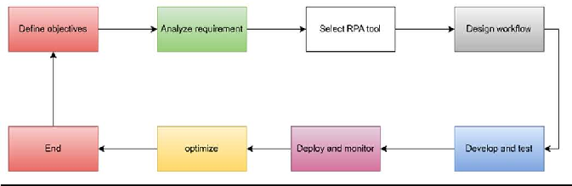
Fig-1 Steps

Step 1: Define Objectives

- Automate the identification of low attendance records and send notification emails.
- Ensure accuracy and timeliness in email communication.
- Provide a mechanism for tracking and logging email communication.

Step 2: Analyze Requirements

- Data Source:
  - Identify the system or database where attendance records are stored (e.g., HR systems, ERP, or spreadsheets).

Attendance Threshold:
  - Define what constitutes “low attendance” (e.g., below 75%).

Email Templates:
  - Prepare standard email templates with placeholders for dynamic information (e.g., name, attendance percentage).

Recipient Details:
  - Ensure email addresses of employees or students are available and up-to- date.

Logging:
  - Decide how to log sent emails (e.g., in a database, spreadsheet, or audit trail).

Step 3: Select RPA Tool

Choose an RPA platform that supports:

- Integration with databases, spreadsheets, or attendance systems.
- Email automation (SMTP, Gmail, Outlook integration).
- Data manipulation and formatting (e.g., UiPath, Automation Anywhere, or Blue Prism).

Step 4: Design Workflow

- Input Data Processing:
  - Fetch attendance data from the source (e.g., database, CSV file, or application).
  - Filter records below the attendance threshold.

Email Content Preparation:
  - Load the email template.
  - Replace placeholders with dynamic data like name, attendance percentage, and any additional personalized messages.

Email Sending:
  - Use the RPA tool's email automation capability to send emails.
  - Ensure the sender’s email address is configured correctly.

Error Handling:
  - Implement error-handling steps for:
    - Missing email addresses.
    - Connection issues with the email server.
    - Formatting errors in data.

Logging and Reporting:
  - Log details of sent emails (e.g., timestamp, recipient, success/failure status).
  - Generate summary reports for stakeholders.

Step 5: Develop and Test

- Build the Automation:
  - Create the RPA bot using the selected tool.
  - Ensure modularity for ease of updates and troubleshooting.

Test:
  - Test with sample data to verify:
    - Correct identification of low attendance records.
    - Accurate email content generation.
    - Smooth sending and logging.

Step 6: Deploy and Monitor

- Deploy:
  - Schedule the bot to run periodically (e.g., daily, weekly) as required.

Monitor:
  - Regularly monitor logs to ensure the process runs smoothly.
  - Address failures promptly.

Step 7: Optimize

- Feedback Loop:
  - Collect feedback on email accuracy, content, and effectiveness.

Enhancements:
  - Incorporate dynamic thresholds or advanced analytics to improve targeting.
  - Add escalations (e.g., notify supervisors if attendance doesn’t improve).
- Email Automation: Outlook, Gmail API, or SMTP integration.
- RPA Platforms: UiPath, Automation Anywhere, Blue Prism.

Error Handling and Text Correction

In cases where the system is unsure of the gesture classification, it can offer suggestions for possible words, powered by natural language processing models. This improves accuracy by considering contextual information.

The complete process can be summarized as follows:

  - Classify gestures using pre-trained models (CNN-based).
  - Display the translated text in real-time on the GUI.

By employing machine learning and computer vision techniques, the system achieves an efficient real- time sign language to text conversion tool that is both scalable and practical for everyday use.

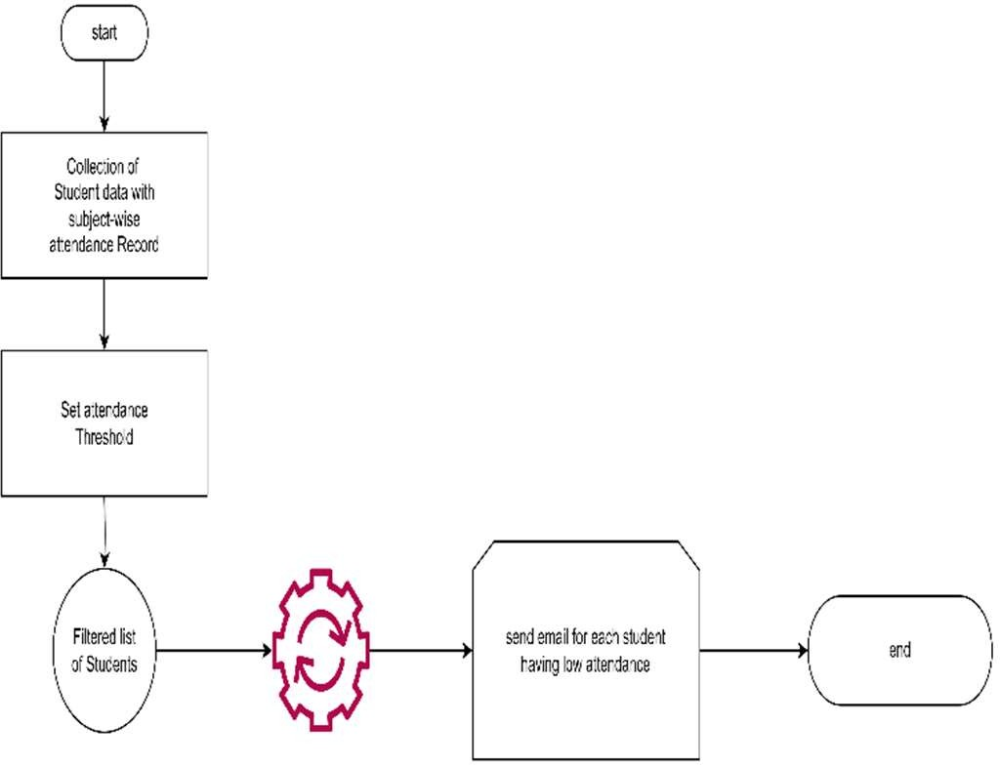

Fig 2: Data Flow Diagram.

Example Tools and Technologies

- Data Processing: Excel, SQL databases.

Result:
Automatic Email Generation for Low Attendance The Automation Anywhere bot effectively automates the process of identifying students with attendance below a specified threshold and sending email alerts. The steps are as follows:
- Open Attendance File The bot accesses an Excel file (Att.Record.xlsx) containing student attendance data.
- Extract Data
Data from the active worksheet is stored in a data table for processing.
- Iterate Through Rows Using a loop, each row is processed, extracting details such as the student name, attendance percentage, and email ID.
- Attendance Check
For each row, the bot checks if the attendance percentage is below 75%.
- Send Email
If the condition is met, the bot sends an email to the student's email ID, notifying them of their low attendance.
- Log Details
A message box displays the details of students with low attendance for verification.
- Close File
The Excel file is closed after processing all rows.
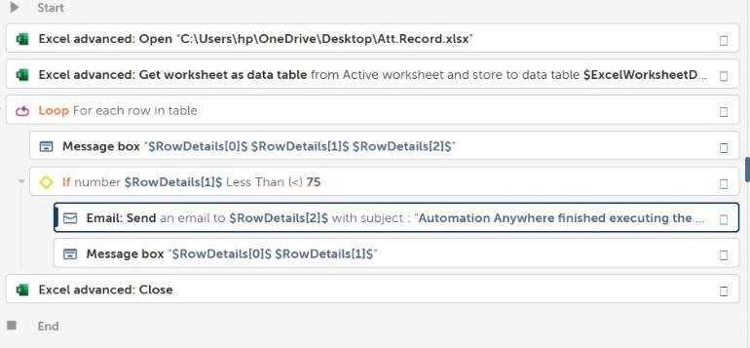
Fig: Code implementation

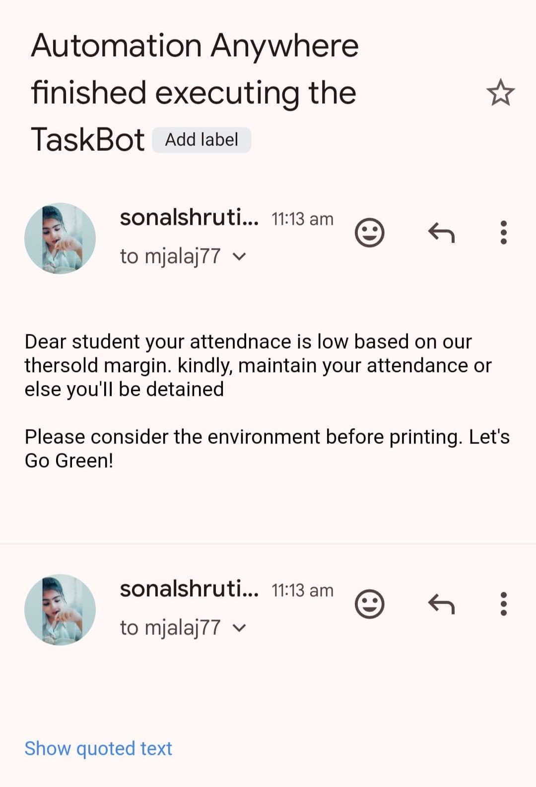
Fig: Alert received

Conclusion:
E-mail automation for low attendance ensures timely, accurate, and efficient communication, reducing manual effort and errors. It enhances accountability through detailed logging and is scalable for broader use cases. This solution streamlines operations, improves responsiveness, and lays a foundation for leveraging automation in future organizational processes.
Future work will focus on Enhancement with predictive analytics, integrate escalation workflows, support multi-language templates, and expand to monitor other performance metrics.

Acknowledgement:
We would like to express our sincere gratitude to Mr. Rakesh Raushan, our project supervisor, for his guidance and support throughout this project. We also thank the Greater Noida Institute of Technology for providing the resources necessary for the completion of this research. Additionally, we appreciate the contributions of the developers who developed tools such as UiPath and Automation Anywhere which gave us a free hand in deploying a bot for automating our tasks for email generation.

REFERENCES:

[1]. Jacksi, Karwan & Mohammed, Falah. (2018). Student Attendance Management System. International Journal of Engineering and Technology. 6. 49-53. 10.21276/sjet.2018.6.2.1..
[2]. Xiaoxue Zong and Kang Feng "Research on intelligent attendance management system based on face recognition technology", Proc. SPIE 13071, International Conference on Mechatronic Engineering and Artificial Intelligence.(MEAI 2023),130713K (28 February 2024);
https://doi.org/10.1117/12.3025538
[3]. Attendance Management System using RPA", International Journal of Emerging Technologies and Innovative Research (www.jetir.org), ISSN:2349- 5162, Vol.8, Issue 10, pageno.136-140,October- 2021,Available
:http://www.jetir.org/papers/JETIRFD06017.pdf
[4]. Mohamed, S.A.; Mahmoud, M.A.; Mahdi, M.N.; Mostafa, S.A. Improving Efficiency and Effectiveness of Robotic Process Automation in Human Resource Management. Sustainability 2022, 14, 3920. https://doi.org/10.3390/ su14073920
[5]. Prof. Snehal Thorave, Dinesh Choudhary, Pratik Adangale, Abhinandan Bankar, Mayur Garde Robotic Process Automation (RPA) in Education Industry 5May 2022
[6]. Choudhury, T., & Mitra, S. (2021). Implementation of Robotics Process Automation in Educational Sector: A Review. International Journal of Advanced Science and Technology, 30(5), 3427- 3433.
- Cho, Y., & Lee, J. (2020). Design and implementation of a personalized learning system using robotics process automation in higher education. Sustainability, 12(20), 8616.
- Garg, P., & Choudhary, P. (2020). Robotics process automation in education: A review. International Journal of Emerging Trends in Engineering Research, 8(10), 3184- 3189.
- Huang, X., & Li, Y. (2021). Applying Robotics Process Automation to Enhance the Teaching Quality of Online Engineering Education. Journal of Educational Technology Development and Exchange, 14(1), 1-18.
- Hu, W., & Xu, X. (2020). The Application of Robotics Process Automation Technology in Education Management. Journal of Physics:
Conference Series, 1666(1), 012001
- Kuppusamy, Palanivel Joseph K, Suresh. (2020).Robotic Process Automation to Smart Education.3775.
- Alcatel-Lucent, (2019). Why Digital Transformation for Education?
- Karl Utermohlen, (2019). Four Ways Machine Learning Is Shaping the Future of Education
- Ibtehal Talal Nafea, (2018). Machine Learning in Educational Technology, 176-182.
http://dx.doi.org/10.5772/intechopen.72906
- Savaram Ravindra, (2018). Role of IoT in Education

